Software Requirement Specification Document

For

Air Traffic Controller Educator

Table of Contents

- Introduction
  - Purpose
  - Intended Customers/Users
  - Product Scope
  - Outline of the document
- Overall Description
  - Product Perspective
  - Product Functions
  - User Classes
  - Design and Implementation Constraints
- Use Case Requirements
  - UML Designs
  - DFD Diagrams
  - ER Diagrams
- Interfaces
  - User Interfaces
  - Hardware Interfaces
  - Software Interfaces
  - Communication Interfaces
- Non-Functional Requirements
  - Performance Requirements
  - Safety Requirements
  - Security Requirements
  - Software Quality Attributes

Chapter I : Introduction

  - Purpose

The primary purpose of this software is to provide an interactive, 2D UI-based learning solution for students and enthusiasts invested in the world of aviation to understand the depths of Air Traffic Control (ATC). This software aims to make it simpler for learners of all experience levels. Various sectors can be practiced upon such as Ground, Tower, Approach and Center control. This document specifies the functional and non-functional requirements to ensure a clear understanding between the developer and the stakeholders involved.

  - Intended Customers / Users

This software is aimed to be of use for the following groups:

- Aviation Students : People enrolled in a Pilot or ATC training programs requiring more practice or to brushen up skills.
- Flight Simulation Enthusiasts : Hobbyists who look into learning further into field for in-depth simulations.
- Aviation Instructors : Educators who could use such tools to aid their teaching
- Self-Learners : Individuals looking to understand airspace management.

  - Product Scope

This Software is a standalone 2D educational simulator. It provides users with a top down view of various airspace levels such as ground, tower, approach and center. It requires them to manage simulated airplanes through UI interactions. This system focuses on teaching standard phrases, sequencing the aircrafts, hand off procedures between different sectors of aviation.

  - Outline of the Document

This document is organized into the following chapters to provide detailed specification:

Chapter 1 (Introduction): Defines the purpose, scope and target audience.

Chapter 2 (Overall Description): High level view of the product’s functions and constraints.

Chapter 3 (Diagrams): To visualize system design.

Chapter 4 (External Interface Requirements): Details user, hardware, and software interfaces.

Chapter 5 (Non-Functional Requirements): Lists performance, safety, and security.

Chapter 6 (Testing): Outlines the requirement validation plan.

Chapter-II: Overall Description

2.1 Product Perspective

The “Air Traffic Controller Educator” aims to be a new self-contained tool. It does not require active data from real flights but operates on a local system. It helps by preparing the learner for high-end professional ATC training suites, emphasizing accessibility and foundational learning.

2.2 Product Functions
The core functions of the system are:

User Authentication : Secure login for users and for tracking of their progress.
Sector Selection: Ability to choose specific ATC roles and to prepare for them individually.
Scenario Simulation: Aircrafts are generated and pilots make requests to be addressed.
Phraseology checking: The software provides accurate feedback of the phrases used by the learner whether by voice or by text.
Performance Evaluation: Users are scored based on safety metrics within their simulated operations.

2.3 User Classes and Characteristics
Trainee (Student): Requires an intuitive GUI; uses the software to learn and practice the procedures.

Instructor (Admin): Possesses expert knowledge, Will use the software to mentor and monitor student performance or to create custom scenarios for learners

Guest User: Limited access to basic tutorials. No progress tracking.

2.4 Design and Implementation Constraints

The development of the system is subject to the following limitations:

Hardware : Must run on standard desktop machines with atleast 8 GB ram
Software : The application must be built with a lightweight GUI framework compatible with both Windows and Linux machines
Interface Constraints: It should be a top down perspective of different controllable sectors
Regulatory Rules: The simulation must align with real world ICAO phraseology.
Database Size: Database size must be manageable and be having portability.

Chapter III – Use Case Requirements

3.1 UML Designs

Module 1: User Identity & Session Management
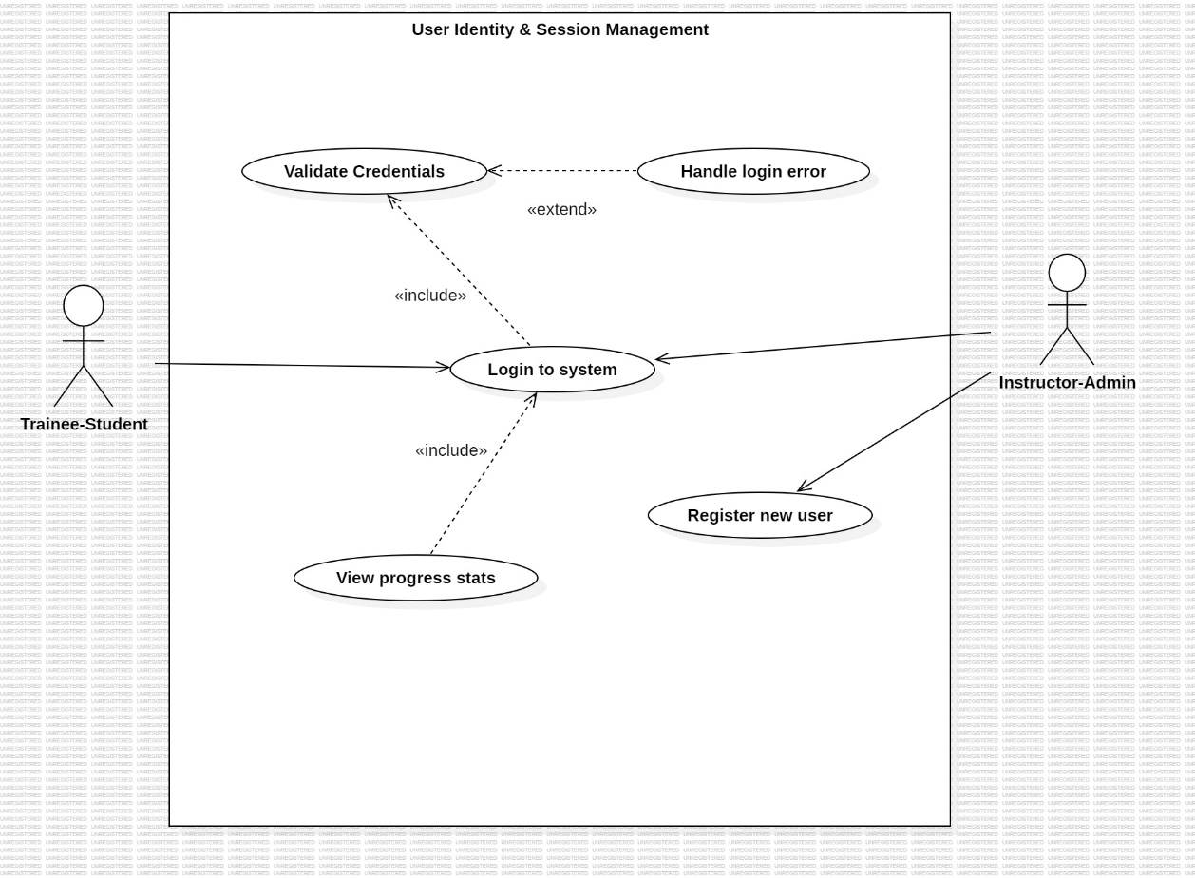
Description: This module manages secure access to the software while allowing for differentiation of both the roles. It handles user verification, registration and initializes the training profile to track and display historical progress statistics.

Primary actors: Trainee-Student, Instructor-Admin.

Secondary actors: none.

Module 2: ATC Operational Simulation
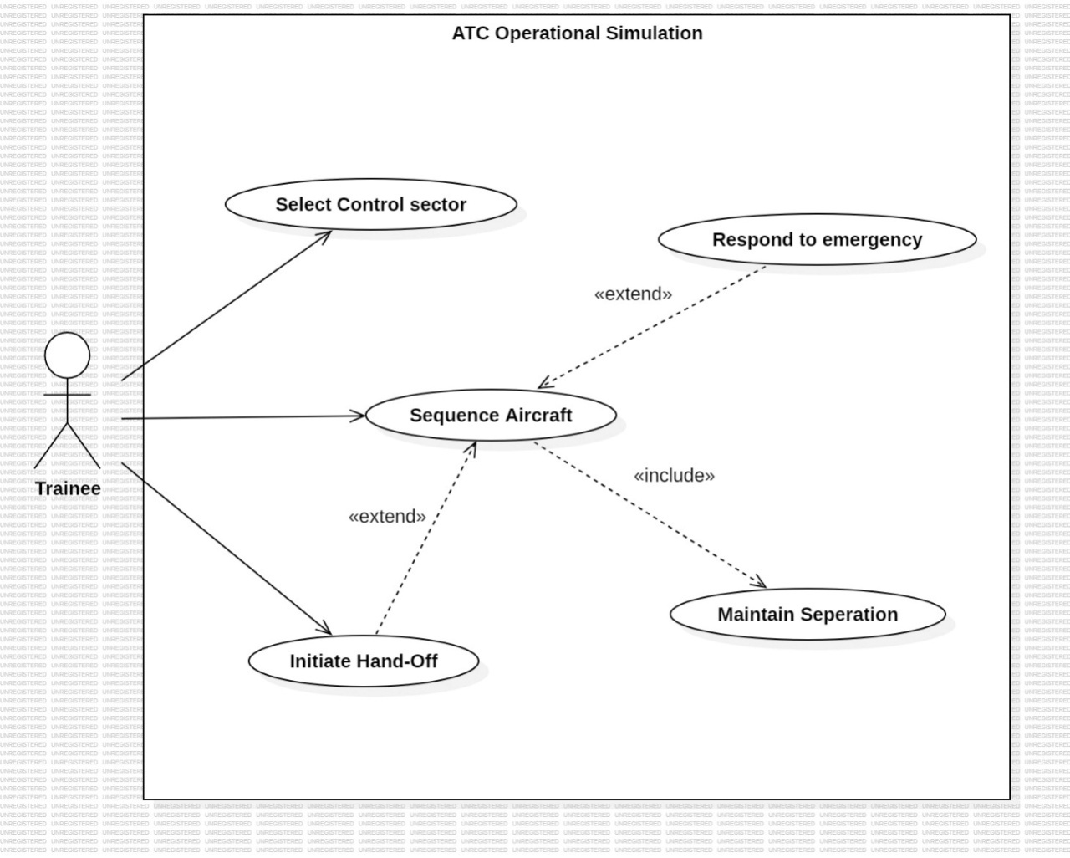
Description: The core 2D simulation engine that provides the radar interface. It allows users to select any sector and practice them. It requires the user to manage active aircraft sequencing and separation. It includes logic for sector hand-offs and responding to emergency scenarios.

Primary actors: Trainee.

Secondary actors: none.

Module 3: Command Validation & Phraseology
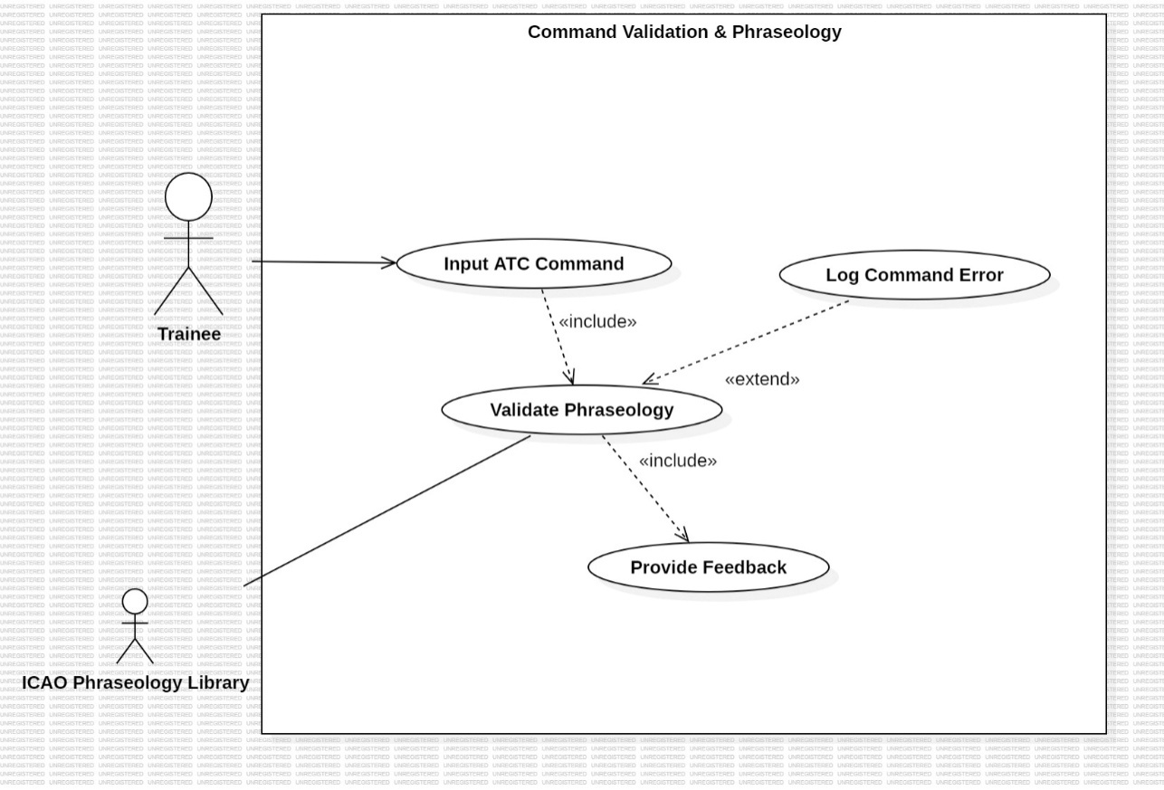
Description: This module processes user commands and verifies them against a library of real-world ICAO standard phraseology. It provides immediate feedback to the learner regarding the accuracy of their instructions.

Primary actors: Trainee.

Secondary actors: ICAO phraseology library.

Module 4: Training Evaluation and Scenario Design
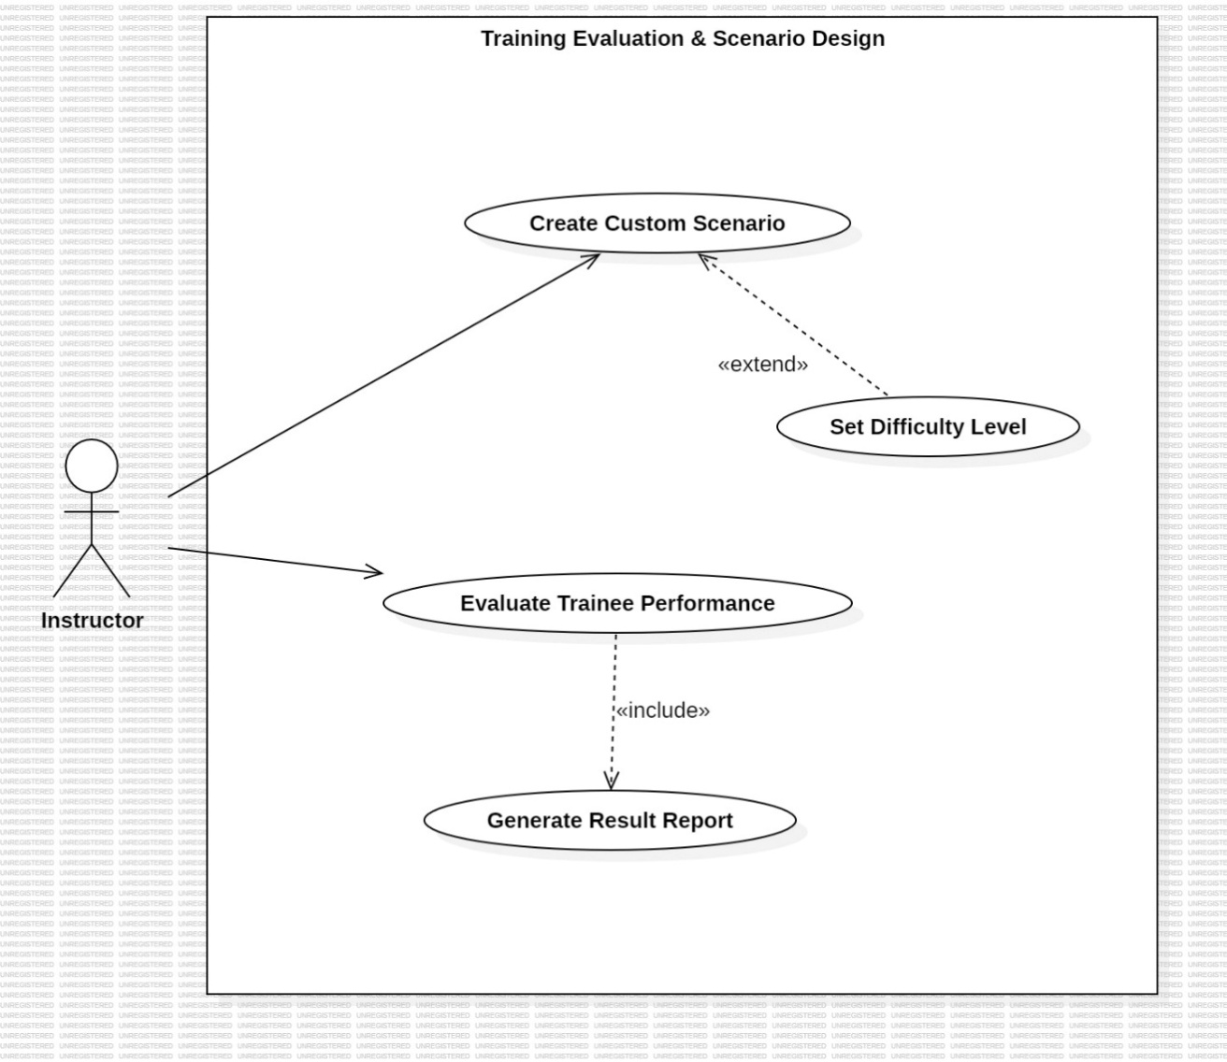
Description: An administrative module that allows instructors to design custom traffic scenarios and adjust difficulty levels. It evaluates trainee performance based on safety metrics and generates detailed result reports.

Primary actors: Instructor – Admin.

Secondary actors: Performance Log Database.

3.1.2 Class Diagrams

Module 1: User Identity & Session Management
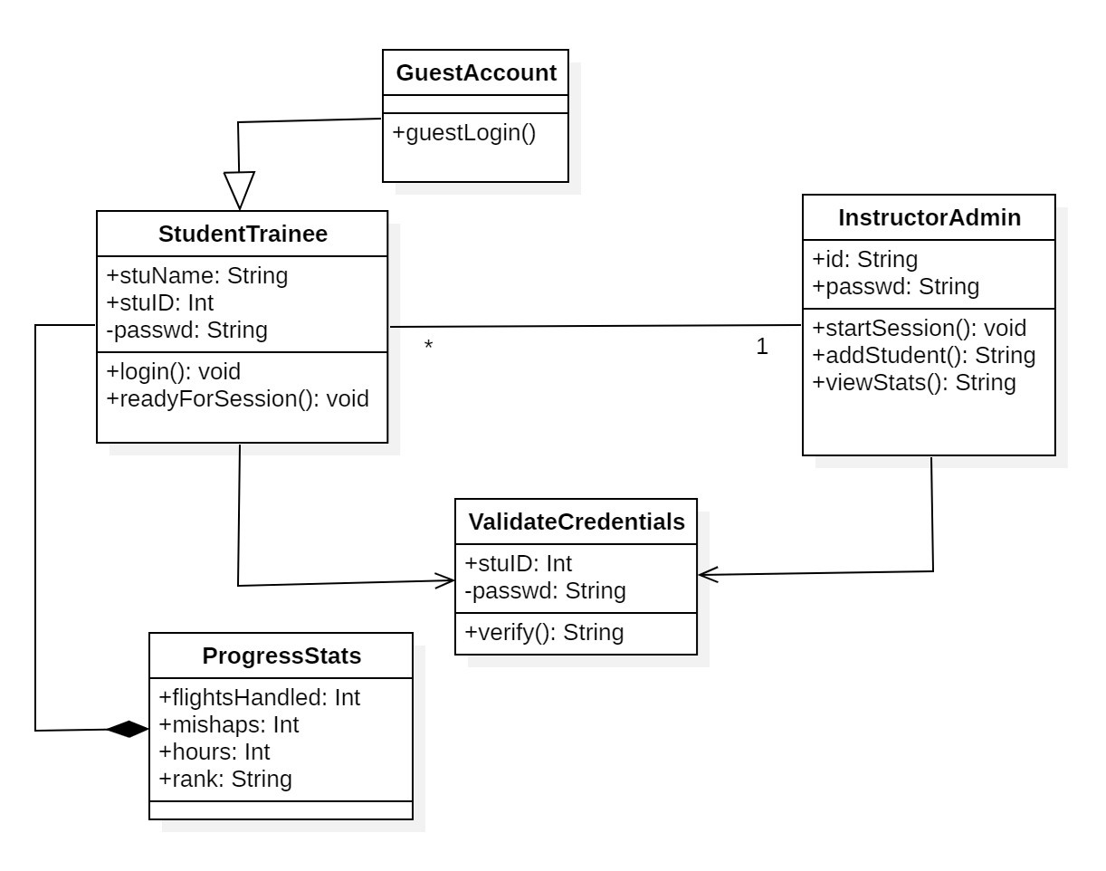
Description:
Defines the class structure for managing user accounts, authentication, and trainee progress within the system.
Classes:
UserAccount,StudentTrainee, InstructorAdmin, GuestAccount, ValidateCredentials, ProgressStats.

Module 2: ATC Operational Simulation
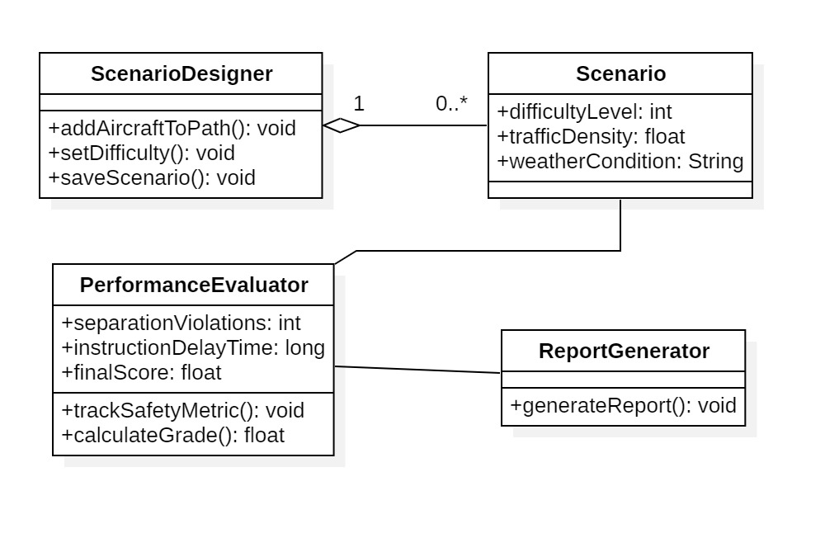
Description:
Defines the class structure for simulating real-time air traffic control operations, including aircraft behavior, airspace sectors, emergency handling, and simulation control logic.
Classes:
SimulationEngine, Aircraft, AirspaceSector, ATCController, EmergencyEvent.

Module 3: Command Validation & Phraseology
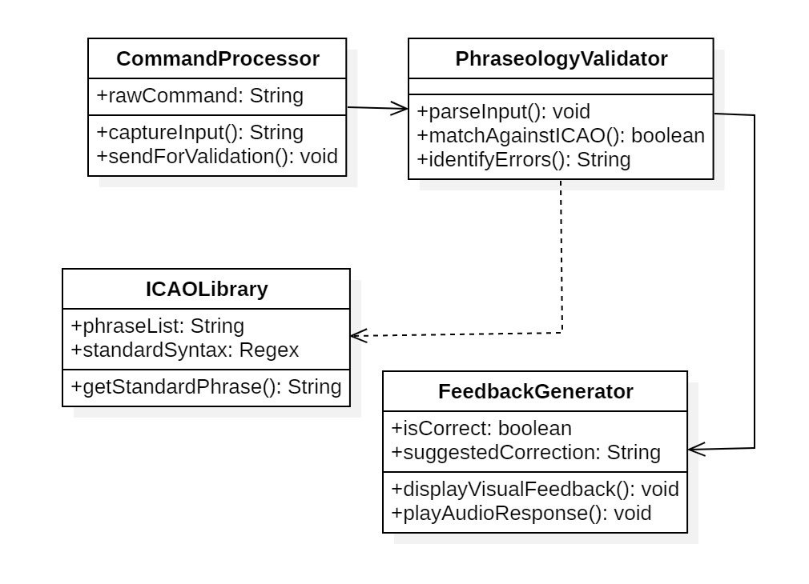
Description:
Defines the class structure for capturing trainee ATC commands, validating them against standard ICAO phraseology, and generating appropriate feedback.
Classes:
CommandProcessor, PhraseologyValidator, ICAOLibrary, FeedbackGenerator.

Module 4: Training Evaluation & Scenario Design

Description:
Defines the class structure for designing training scenarios, evaluating trainee performance based on safety metrics, and generating result reports.
Classes:
ScenarioDesigner, Scenario, PerformanceEvaluator, ReportGenerator.

3.1.3 State Diagrams

Module 4 :Training Evaluation & Scenario Design

State Diagram 1: Scenario Designer
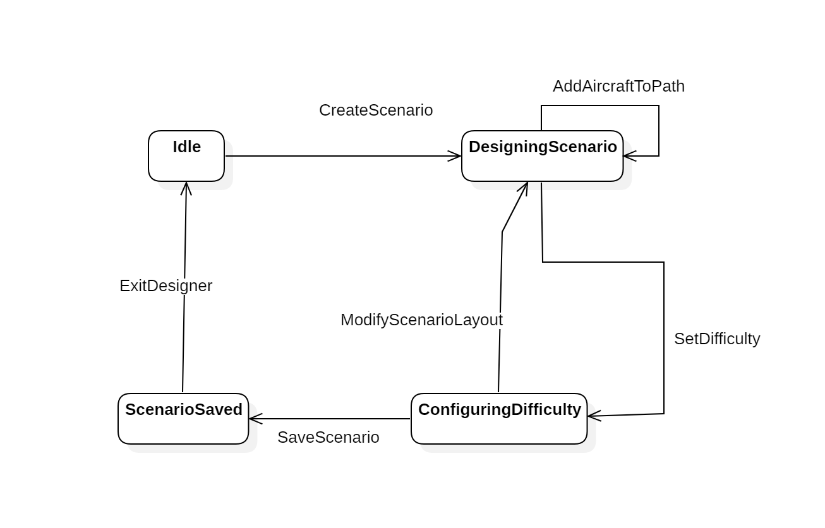
Description:
This state diagram represents the workflow followed by an instructor while designing a custom training scenario. It tracks how scenarios are created, configured, and saved.

States : Idle, Designing Scenario, Setting Difficulty, Scenario Saved

Transitions : Create Scenario, AddAircraftToPath, SetDifficulty, SaveScenario

State Diagram 2 : Scenario
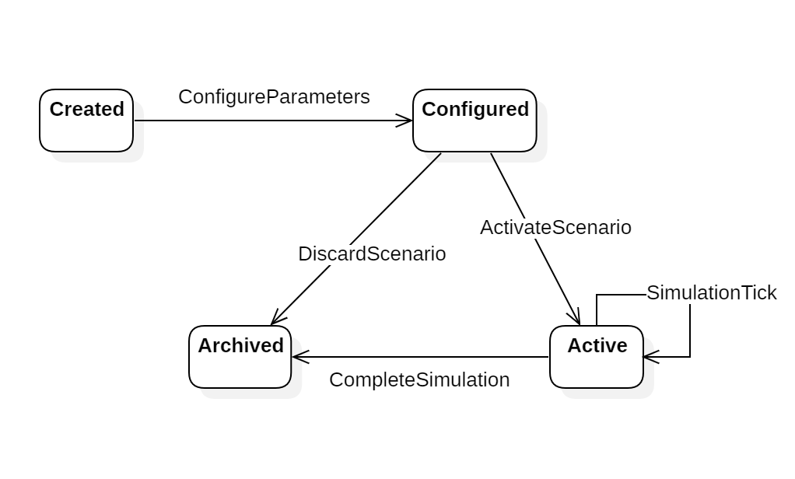
Description:
This state diagram models the lifecycle of a scenario from its creation to execution and archival after use in a training session.

States: Created, Configured, Active, Archived

Transitions: ConfigureParameters, ActivateScenario, CompleteSimulation, ArchiveScenario

State Diagram 3 : PerformanceEvaluator
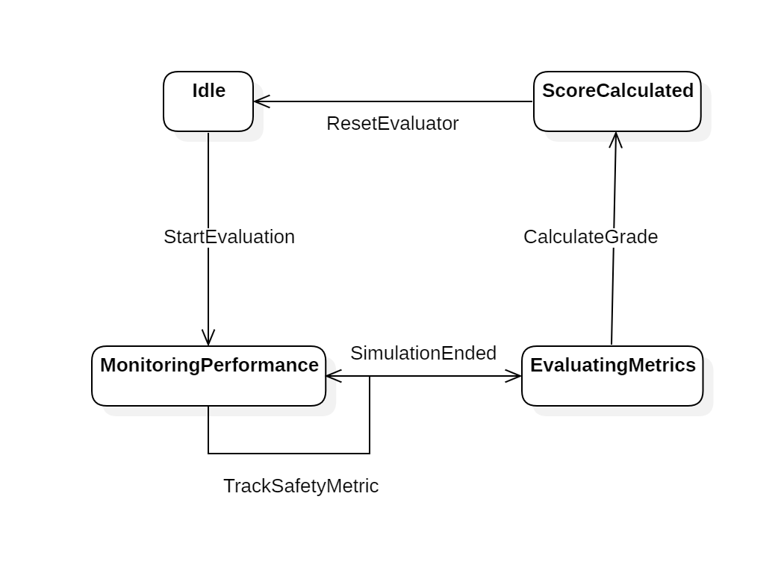
Description:
This state diagram represents the evaluation process of a trainee’s performance during a simulation. It tracks how safety metrics are monitored, processed, and converted into a final score.

States: Idle, MonitorPerformance, EvaluatingMetrics, ScoreCalculated

Transitions: StartEvaluation, TrackSafetyMetric, CalculateGrade, EvaluationComplete

State Diagram 4: ReportGenerator
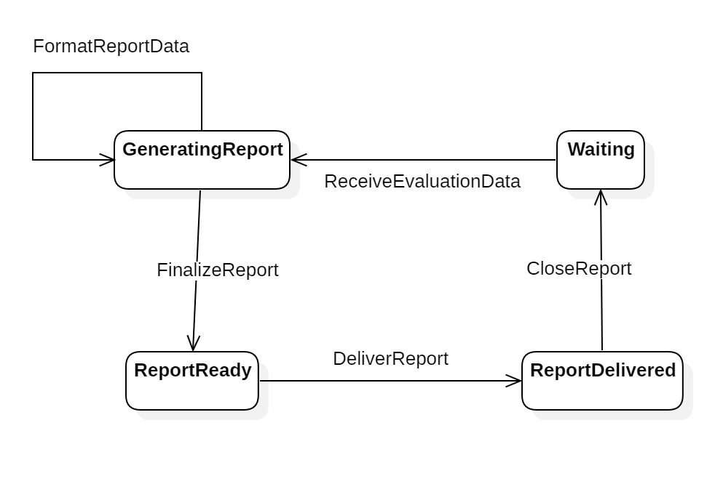
Description:
This state diagram models the generation of a performance report after evaluation is completed. It tracks the flow from receiving evaluation data to producing and finalizing the report.

States: Waiting, GeneratingReport, ReportReady, ReportDelivered

Transitions: RecieveEvaluationData, GenerateReport, FinalizeReport, DeliverReport

3.1.4 Activity Diagrams

Module 1: User Identity & Session Management
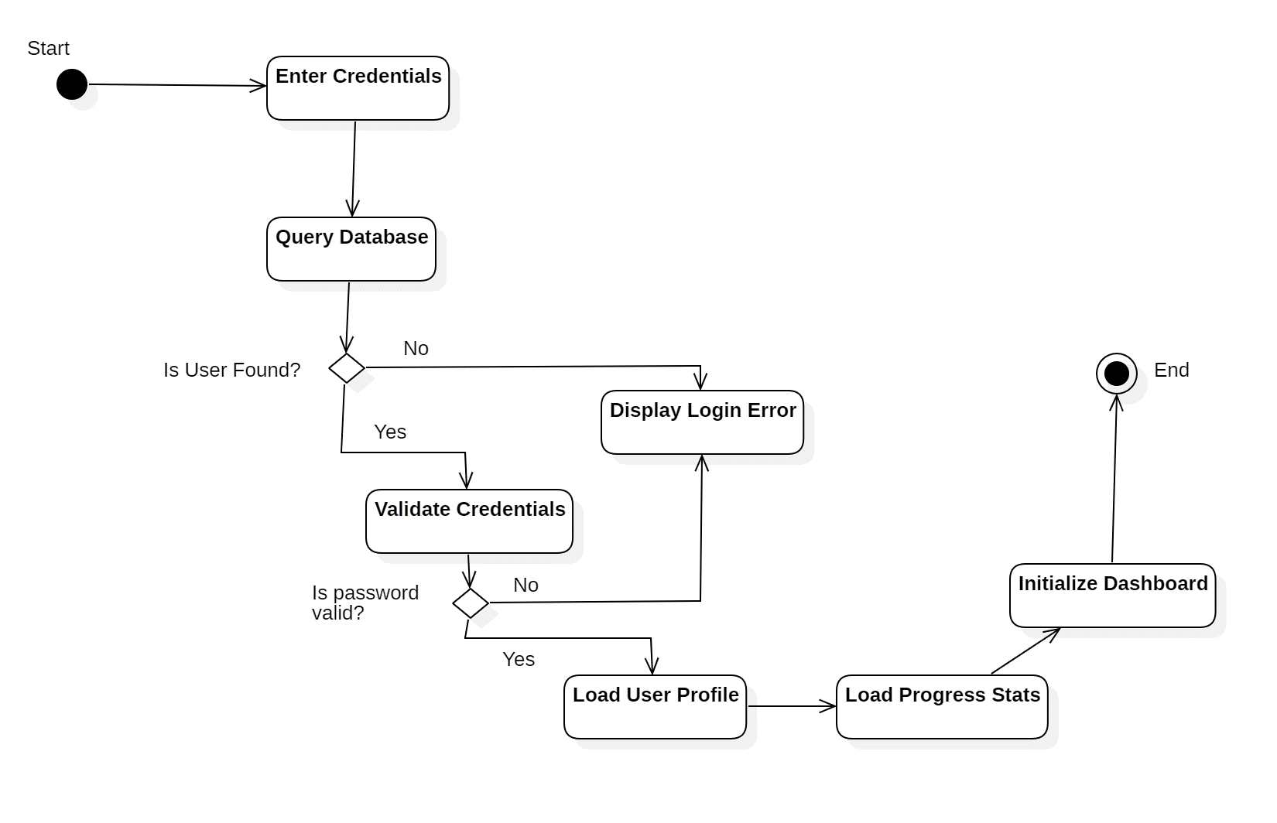
Description: Represents the workflow for user login, credential validation, profile loading, and dashboard initialization, including handling of invalid login attempts.

Activities: Enter Credentials, Query Database, Validate Credentials, Load User Profile, Load Progress Stats, Initialize Dashboard, Display Login Error

Decision Points: Is User Found? , Is Password Valid?

Module 2 : ATC Operational Simulation
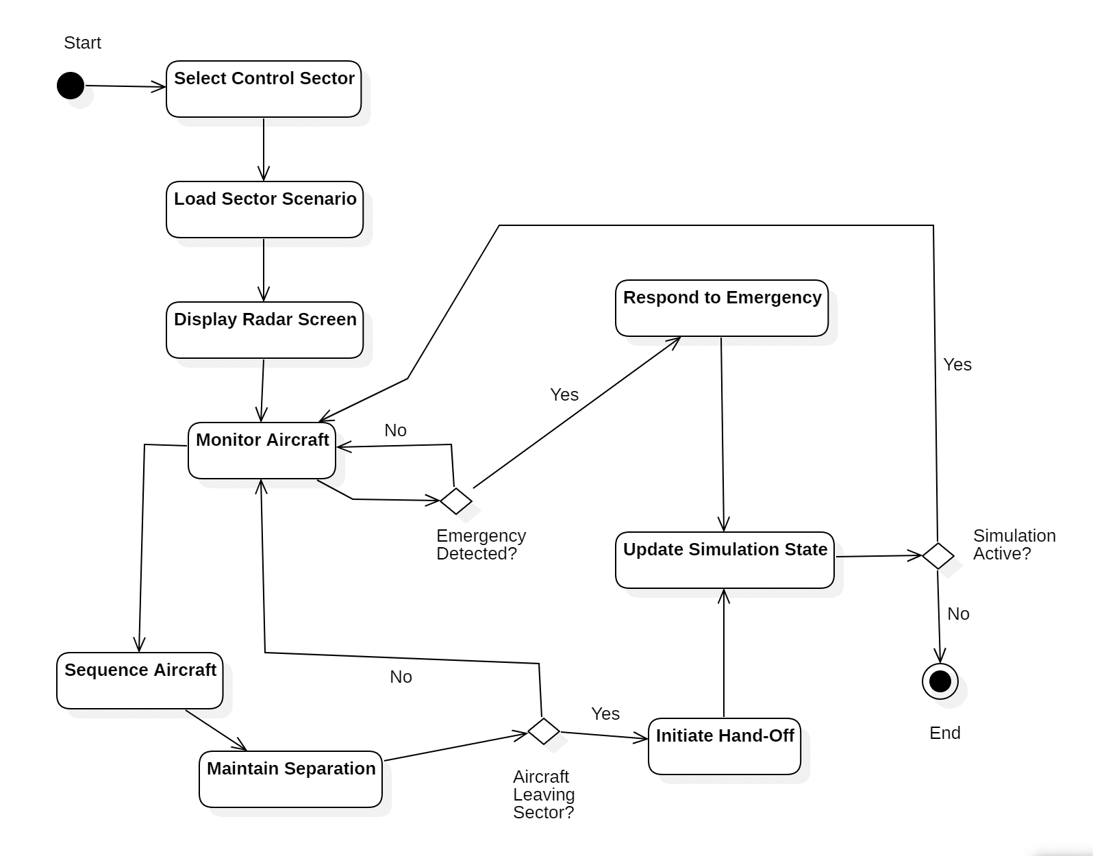
Description: Represents the operational flow of the ATC simulation where the trainee monitors aircraft, maintains separation, handles emergencies, manages sector hand-offs, and controls the simulation loop.
Activities: Select Control Sector, Load Sector Scenario, Display Radar Screen, Monitor Aircraft, Sequence Aircraft, Maintain Separation, Respond to Emergency, Initiate Hand-Off, Update Simulation State
Decision Points: Emergency Detected?, Aircraft Leaving Sector?, Simulation Active?

3.1.5 Sequence Diagrams

- User Login Process

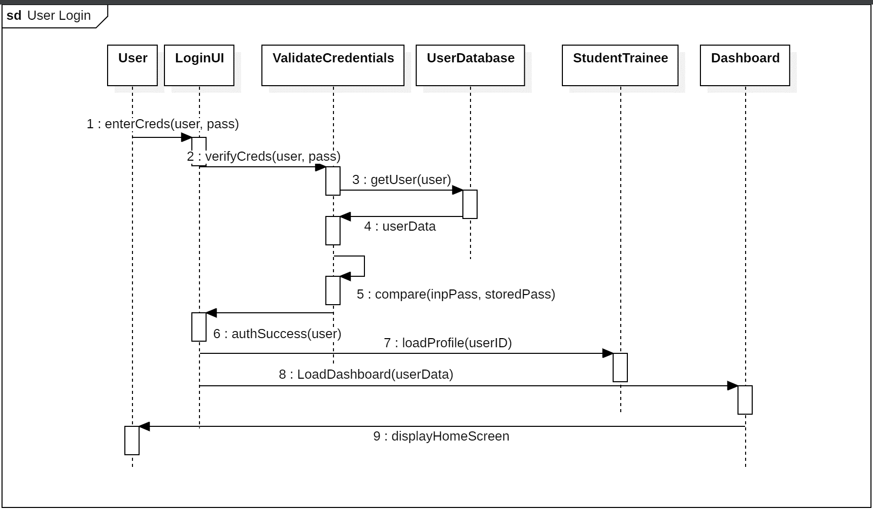

Description:This sequence diagram illustrates the interaction between user interface, authentication logic, and database during user login. It shows credential validation, user data retrieval, and dashboard initialization upon successful authentication.

- ATC Operational Simulation

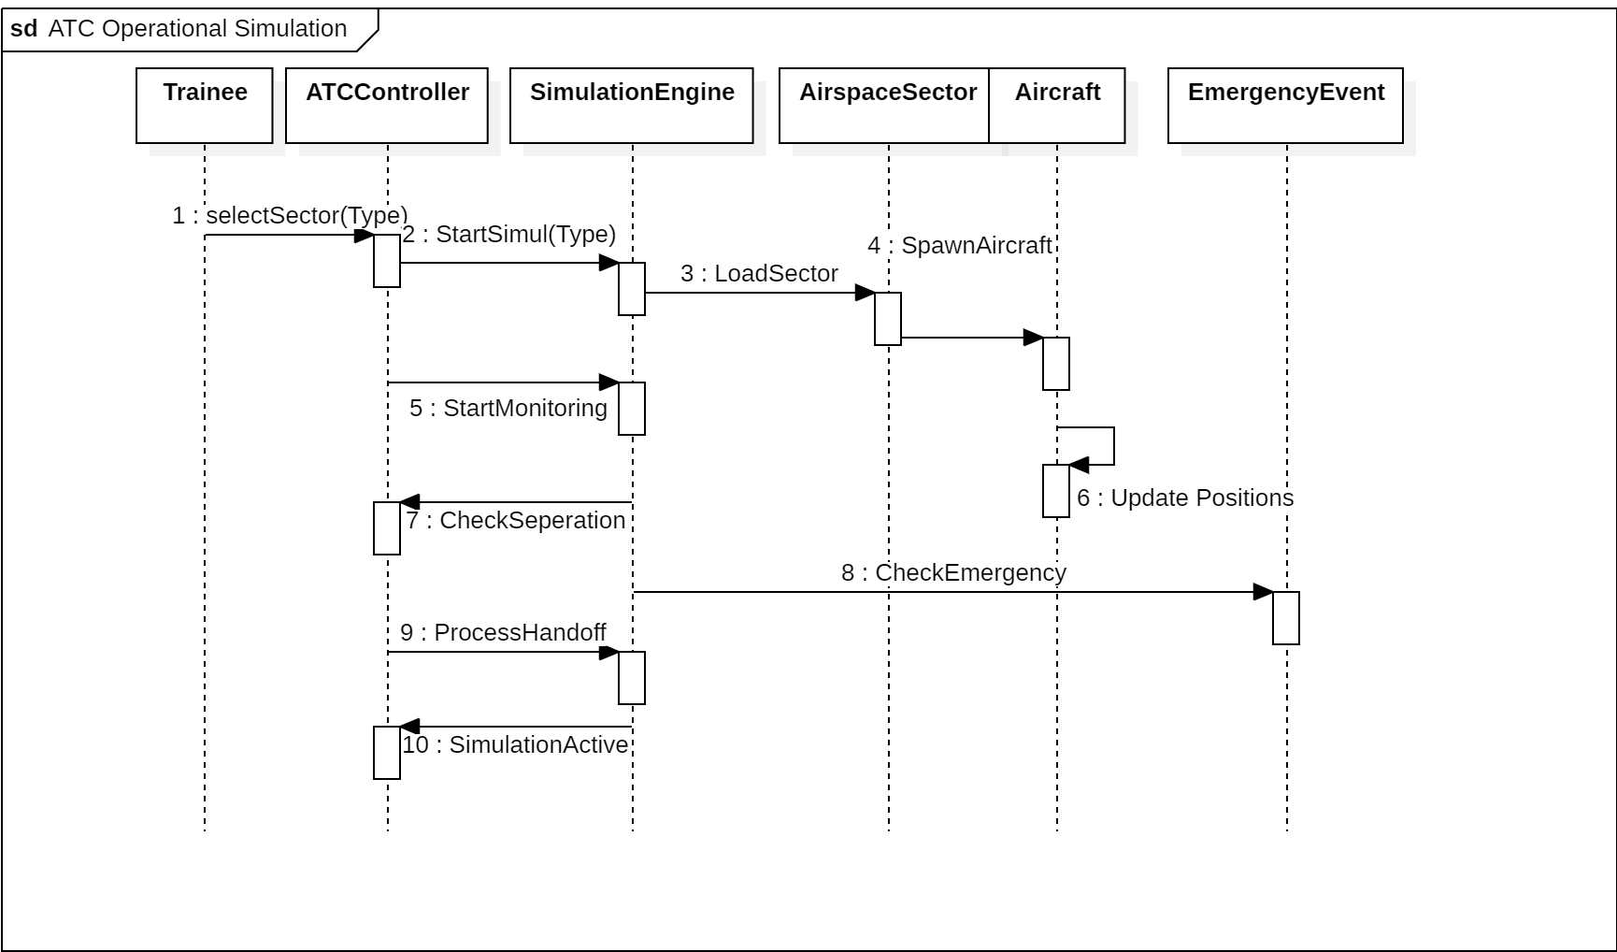

Description: This sequence diagram illustrates the interaction between trainee input, simulation engine, aircraft objects, and emergency handling during an ATC simulation session. It demonstrates sector initialization, aircraft monitoring, separation checking, emergency response, and hand-off processing within a continuous simulation loop.

3.1.6 Communication / Collaboration Diagrams

- Login Process
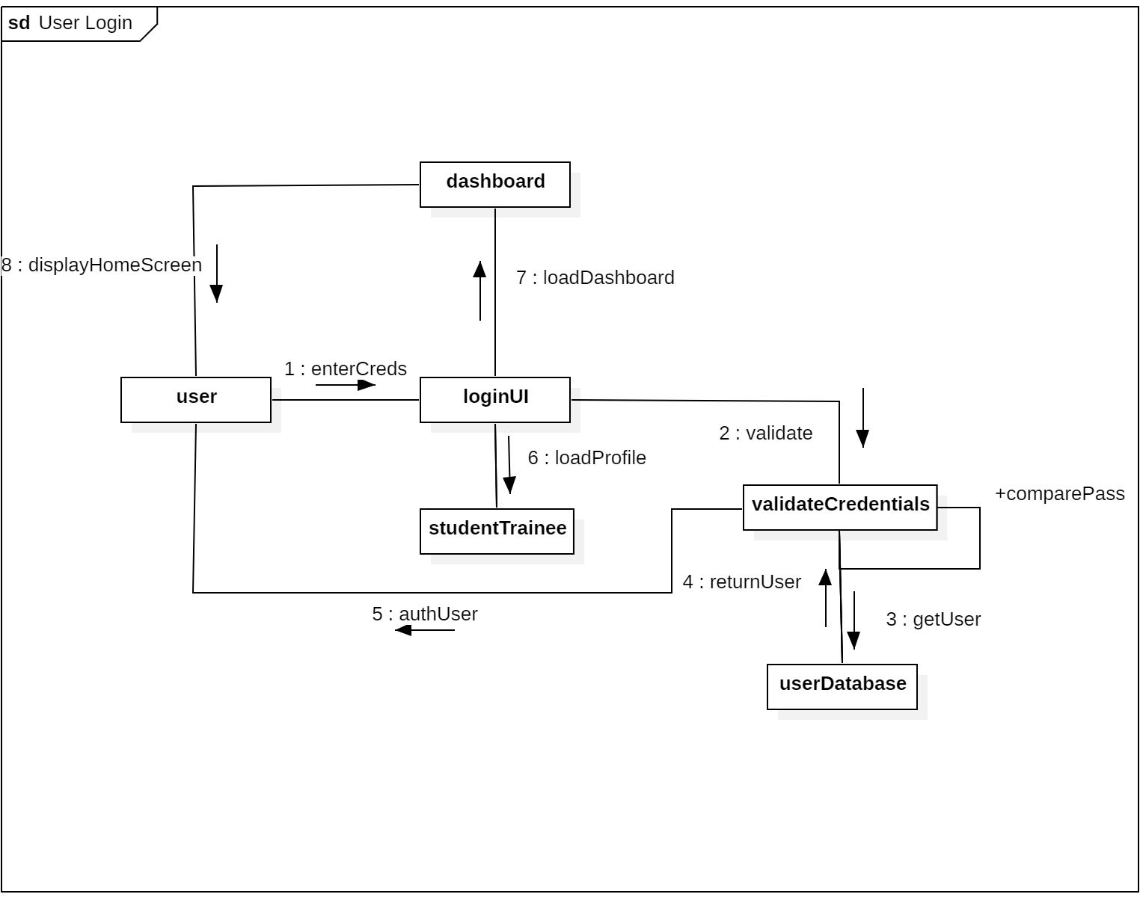

Description: This diagram shows the interaction between UI, validation logic, database, and user objects during the login process. It illustrates how credentials are verified and how the dashboard is initialized upon successful authentication.

- ATC Operation Simulation

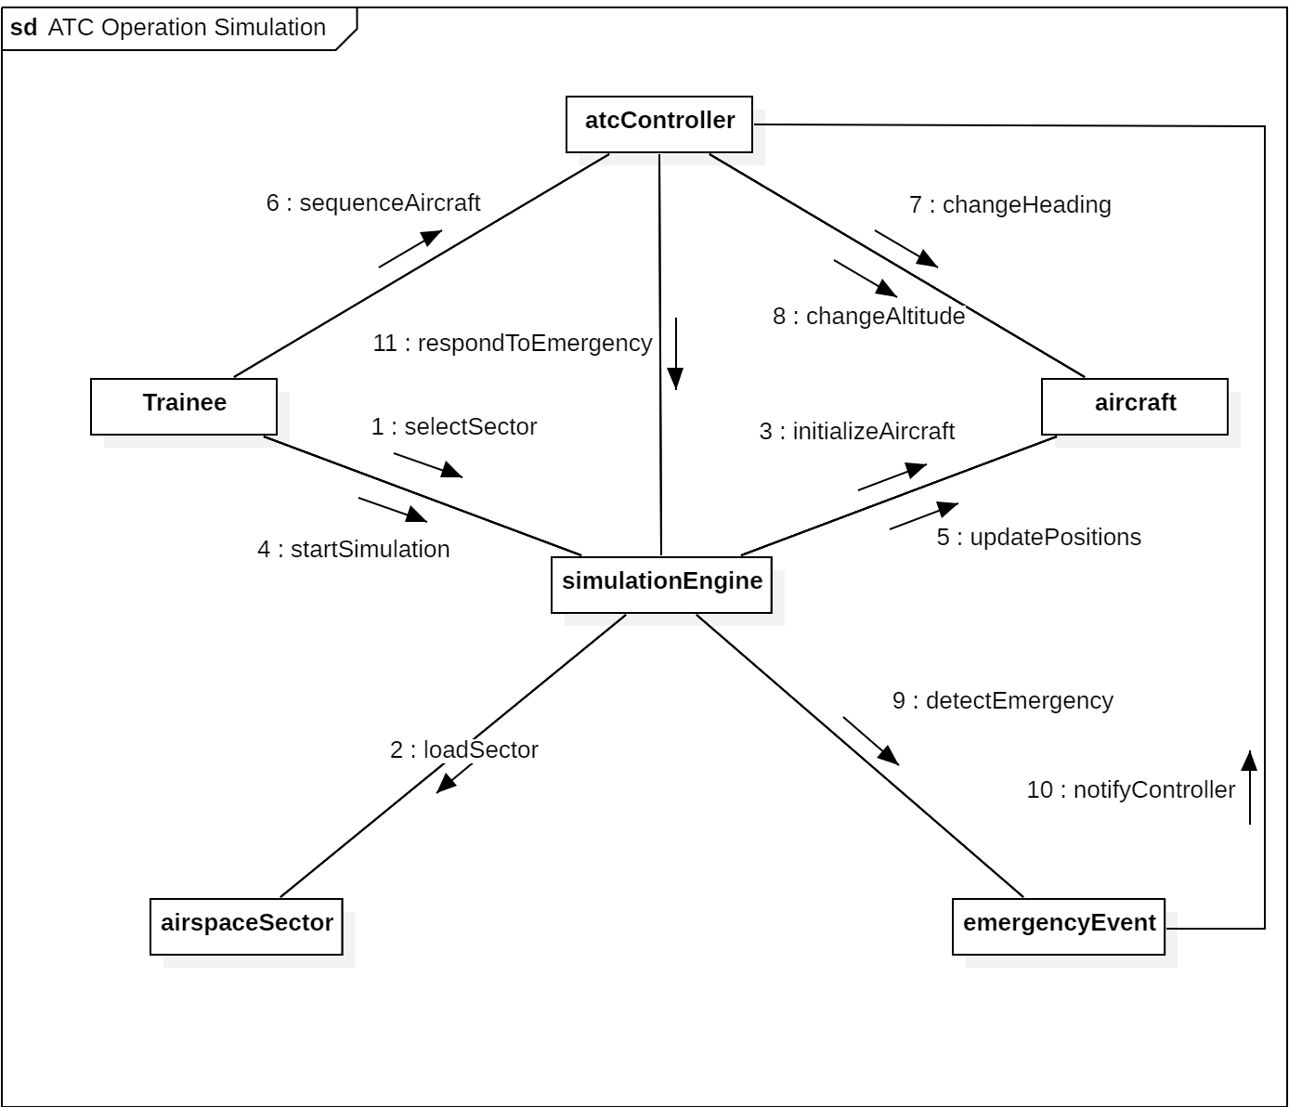

Description: This diagram illustrates the interaction between the trainee, simulation engine, aircraft, and controller objects during live ATC operations. It shows how sector selection, aircraft sequencing, separation monitoring, and emergency handling are coordinated through message exchanges.

3.2 DFD Diagram

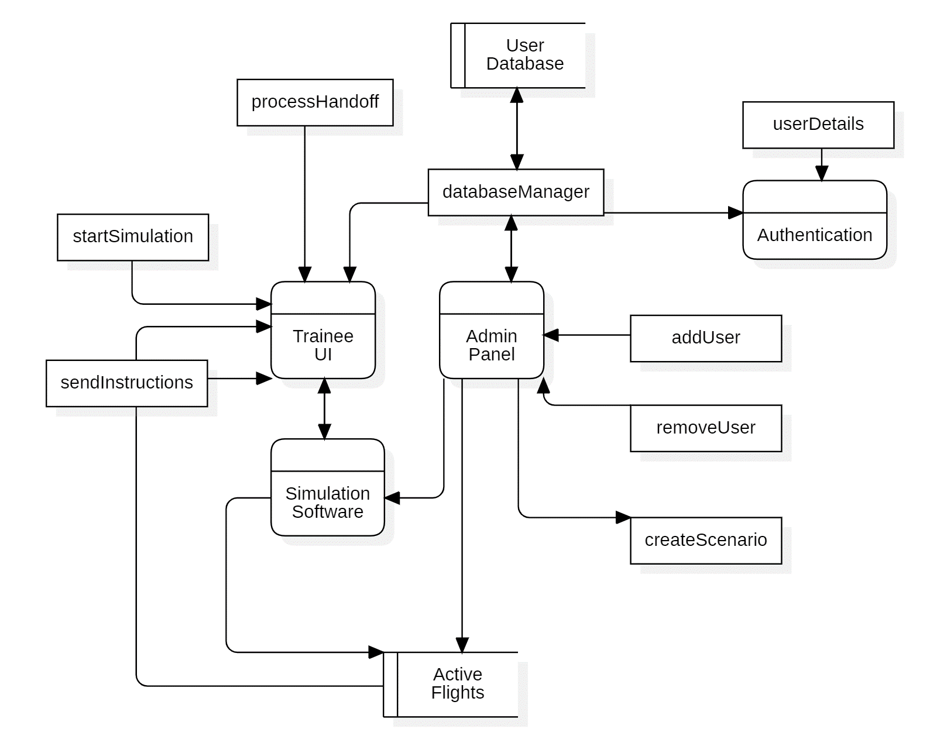

Description:
Represents the flow of data between the Trainee UI, Admin Panel, Authentication system, Simulation Software, and supporting data stores. It illustrates how user credentials are verified, how simulation commands are processed, and how administrative actions such as user management and scenario creation interact with the database and active flight data.

External Entities:
Trainee, Admin.
Processes:
Authentication, Trainee UI, Admin Panel, Simulation Software, Database Manager.
Data Stores:
User Database, Active Flights.
Major Data Flows:
User Details, Start Simulation, Send Instructions, Process Handoff, Add User, Remove User, Create Scenario.

3.2 ER Diagram

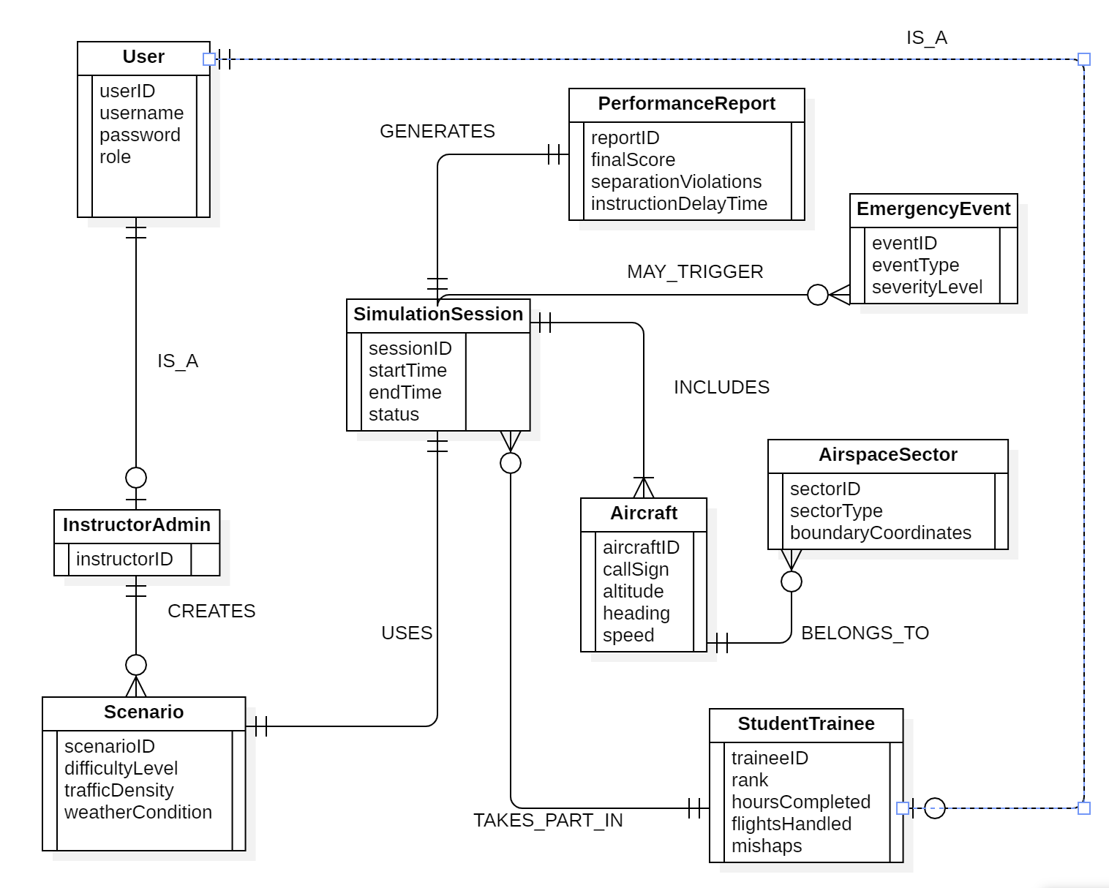

Description:
Represents the database structure of the ATC Training System. It defines user roles, simulation sessions, aircraft management, scenario configuration, emergency handling, and performance evaluation. The diagram models entity relationships, primary keys, foreign keys, and cardinality constraints to ensure structured data storage and retrieval.

Chapter IV – Interfaces

4.1 User Interfaces:
Admin Interface: Allows instructors to manage users, create scenarios, adjust difficulty levels, and view trainee performance reports.
Trainee Interface: Provides radar view, aircraft control tools, phraseology feedback, and performance scoring during simulation.
Guest Interface: Provides limited access to demo scenarios without progress tracking.

4.2 Hardware Interfaces:
  - Computer
  - Tablet
  - Servers
  - Microphone

4.3 Software Interfaces:
  - Operating System(Mac / Windows / Linux)
  - Database(MongoDB)
  - FlightRadar24 API
  - GUI Framework : Lightweight cross-platform GUI

4.4 Communication Interfaces:
  - HTTPS / HTTP
  - Internet
  - Wi-fi/LAN
  - Rest API

Chapter V – Non-Functional Requirements

5.1 Performance Requirements
• The system shall respond to user actions within 2 seconds.
• The simulation engine shall handle multiple aircraft without noticeable lag.
• The system shall support at least 50 concurrent aircraft objects in a session.
• Database queries shall complete within 1 second.

5.2 Safety Requirements
• The system shall prevent loss of trainee progress data.
• Automatic backup of performance logs shall be maintained.
• The system shall handle simulation errors without crashing.
• Emergency scenarios shall not corrupt session data.

5.3 Security Requirements
• Only authenticated users shall access the system.
• User passwords shall be encrypted in the database.
• Session timeout shall occur after inactivity.

5.4 Software Quality Attributes
• Reliability: The system shall operate without unexpected crashes.
• Usability: The interface shall be intuitive and beginner-friendly.
• Scalability: The system shall allow future expansion of sectors and scenarios.
• Maintainability: The code structure shall support modular updates.
• Portability: The software shall run on Windows and Linux platforms.

5.5 Business Rules / Policies
• The system should follow ICAO standard phraseology.
• Simulation procedures should be identical with real-world ATC standards.
• No specific legal or financial policies are applicable.

Chapter V – Testing

6.1 White-Box Testing
White-box testing (also referred to as glass-box or structural testing) tests the internal logic of the code directly. The basis path testing technique is used here, which requires drawing a control flow graph, calculating cyclomatic complexity, identifying independent execution paths, and designing one test case per path.

6.1.1 Module 1 : User Session Management – register()
The register() function handles new user creation with three sequential validation checks before writing to the user store — making it a suitable candidate for basis path testing.

Step 1 : Control Flow Graph
Each node represents a processing step or decision point. Edges represent the flow of control between them.
Node | Description
1 | Function entry — receive username, password, role
2 | Decision: Is username already registered? (Predicate 1)
3 | Decision: Is len(password) < 6? (Predicate 2)
4 | Decision: Is role not in (trainee, instructor, guest)? (Predicate 3)
5 | Write new user record to users dict
6 | Return / Exit
Edges: 1→2, 2(T)→6, 2(F)→3, 3(T)→6, 3(F)→4, 4(T)→6, 4(F)→5, 5→6
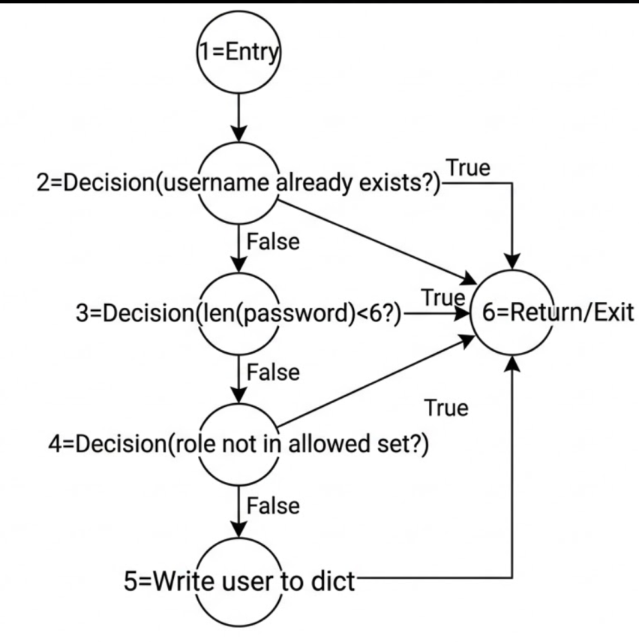

Step 2 : Cyclomatic Complexity
• Method 1 – Regions : Total enclosed regions in flow graph = 4
• Method 2 – Edges and Nodes : V(G) = E − N + 2 = 8 − 6 + 2 = 4
• Method 3 – Predicate Nodes : V(G) = P + 1 = 3 + 1 = 4
Cyclomatic Complexity = 4, meaning 4 independent paths are to be identified and tested.

Step 3 : Independent Paths
Path | Node Sequence | Condition Covered
P1 | 1 → 2(T) → 6 | Username already exists
P2 | 1 → 2(F) → 3(T) → 6 | Password shorter than 6 characters
P3 | 1 → 2(F) → 3(F) → 4(T) → 6 | Role not in the allowed set
P4 | 1 → 2(F) → 3(F) → 4(F) → 5 → 6 | All validations pass — user is registered

Step 4 : Test Cases and Execution
Path | Input | Expected | Actual | Result
P1 | register("alice","pass123","trainee") [duplicate] | "User already exists." | "User already exists." | Pass
P2 | register("u","abc","trainee") | "Password too short." | "Password too short." | Pass
P3 | register("u2","pass123","admin") | "Invalid role." | "Invalid role." | Pass
P4 | register("u3","pass123","trainee") | "Registered successfully." | "Registered successfully." | Pass
All 4 independent paths were executed successfully. White-Box testing for register() is complete.

6.1.2 Module 3 : Command Validation – validate()
The validate() function checks an ATC command string against 10 predefined ICAO regex patterns. It contains an empty-check condition followed by a loop with an inner match condition, giving it sufficient branching complexity for basis path testing.

Step 1 : Control Flow Graph
Nodes and edges for the validate() function are described below.
Node | Description
1 | Function entry — receive command string
2 | Decision: Is command empty or whitespace? (Predicate 1)
3 | Loop condition: Are there more patterns to check? (Predicate 2)
4 | Decision: Does re.match(pattern, command) succeed? (Predicate 3)
5 | Return True, phrase name, and score
6 | Return / Exit
Edges: 1→2, 2(T)→6, 2(F)→3, 3(F)→6, 3(T)→4, 4(T)→5, 4(F)→3, 5→6
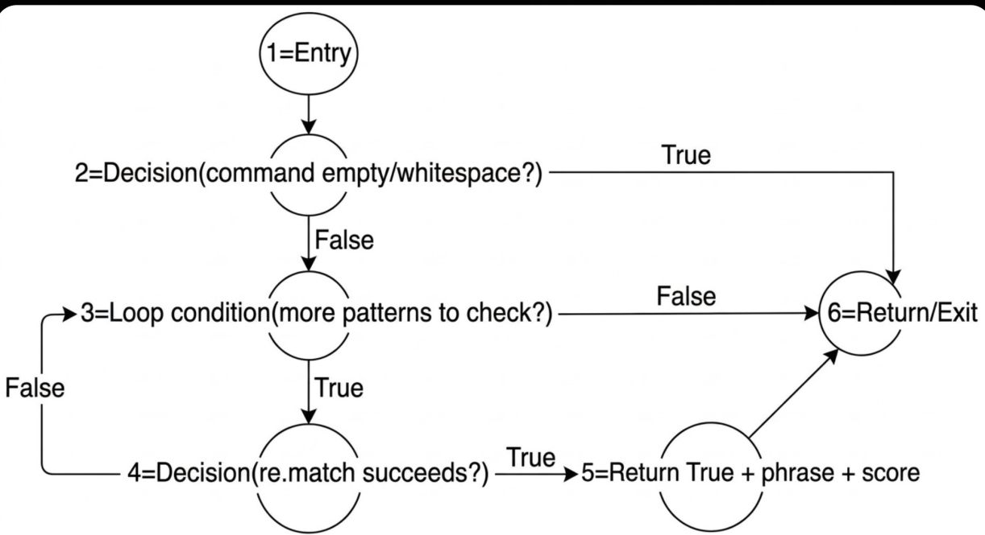

Step 2 : Cyclomatic Complexity
• Method 1 – Regions : Total enclosed regions in flow graph = 4
• Method 2 – Edges and Nodes : V(G) = E − N + 2 = 8 − 6 + 2 = 4
• Method 3 – Predicate Nodes : V(G) = P + 1 = 3 + 1 = 4
Cyclomatic Complexity = 4, meaning 4 independent paths are to be identified and tested.
Step 3 : Independent Paths
Path | Node Sequence | Condition Covered
P1 | 1 → 2(T) → 6 | Command is empty or whitespace-only
P2 | 1 → 2(F) → 3(T) → 4(T) → 5 → 6 | First pattern matches on first iteration
P3 | 1 → 2(F) → 3(T) → 4(F) → … → 4(T) → 5 → 6 | Match found after multiple loop iterations
P4 | 1 → 2(F) → 3(T) → 4(F) → … → 3(F) → 6 | Loop exhausted — no pattern matched
Step 4 : Test Cases and Execution
Path | Input | Expected | Actual | Result
P1 | validate("") | (False, "Empty command.", 0) | (False, "Empty command.", 0) | Pass
P2 | "AAL123, cleared to land runway 27L" | (True, "Cleared to Land", 10) | (True, "Cleared to Land", 10) | Pass
P3 | "DAL456, turn left heading 090" | (True, "Turn Heading", 7) | (True, "Turn Heading", 7) | Pass
P4 | "AAL123, take off runway 27L" | (False, "Invalid ICAO phraseology.", 0) | (False, "Invalid ICAO phraseology.", 0) | Pass
All 4 independent paths were executed successfully. White-Box testing for validate() is complete.

6.2 Black-Box Testing
Black-box testing verifies system behaviour from the user's perspective, without examining the internal code. Two standard techniques are applied here: Equivalence Partitioning (EP) and Boundary Value Analysis (BVA).

6.2.1 Module 1 : User Session Management
Functional requirements used as the basis for test design:
• FR1. Username must be unique; registering a duplicate shall return an error.
• FR2. Password must be at least 6 characters; shorter passwords shall be rejected.
• FR3. Role must be one of: trainee, instructor, or guest.
• FR4. A valid login returns a session token; an invalid username or wrong password returns an error.
• FR5. Only trainee sessions may record scores; instructor sessions shall be rejected.

Equivalence Partitioning
Input | Valid Class | Invalid Class | Rationale
username | Any new, unregistered string | Already-registered name | Unique constraint
password | Length >= 6 | Length < 6 | Minimum length rule
role | "trainee", "instructor", "guest" | "admin", "superuser", or any other | Allowed role set
login: user | Registered username | Unregistered username | Must exist in store
login: password | Correct password for that user | Wrong password | SHA-256 hash must match

Boundary Value Analysis – Password Length (boundary at 6 characters)
Test ID | Input | Expected | Actual | Result
BV1 | register("u1","abcde","trainee") [len=5, below boundary] | "Password too short." | "Password too short." | Pass
BV2 | register("u2","abcdef","trainee") [len=6, at boundary] | "Registered successfully." | "Registered successfully." | Pass
BV3 | register("u3","abcdefg","trainee") [len=7, above boundary] | "Registered successfully." | "Registered successfully." | Pass

EP Execution Results – Module 1
Test ID | Input | Expected | Actual | Result
EP1 | register("alice","pass123","trainee") [duplicate] | "User already exists." | "User already exists." | Pass
EP2 | register("new","abc","trainee") [short password] | "Password too short." | "Password too short." | Pass
EP3 | register("new","pass123","admin") [invalid role] | "Invalid role." | "Invalid role." | Pass
EP4 | register("new3","pass123","instructor") | "Registered successfully." | "Registered successfully." | Pass
EP5 | login("nobody","pass123") [user does not exist] | "User not found." | "User not found." | Pass
EP6 | login("alice","wrongpass") [wrong password] | "Wrong password." | "Wrong password." | Pass

6.2.2 Module 3 : Command Validation
Functional requirements used as the basis for test design:
• FR1. An empty or whitespace-only command shall return (False, 'Empty command.', 0).
• FR2. A command matching a valid ICAO pattern shall return True along with the phrase name and its score.
• FR3. A command that matches no pattern shall return (False, 'Invalid ICAO phraseology.', 0).
• FR4. The callsign must consist of 3 uppercase letters followed by 1 to 4 digits.
• FR5. Runway designators must be two digits, optionally followed by L, R, or C.

Equivalence Partitioning
Input Class | Valid Class | Invalid Class | Rationale
Command content | Matches one of 10 ICAO patterns | Matches no defined pattern | Regex matching logic
Command emptiness | Non-empty, trimmed string | Empty string or whitespace only | Empty-check guard at entry
Callsign format | AAL123, DAL1, UAL9999 | No callsign or wrong format | Regex is anchored to callsign
Phrase keyword | "cleared to land", "hold position" | "land now", "stop", "take off" | Exact keyword match required

Boundary Value Analysis – Callsign Digit Count (boundary: 1 to 4 digits)
Test ID | Input | Expected | Actual | Result
BV1 | "AAL1, cleared to land runway 27L" [1 digit, min] | (True, "Cleared to Land", 10) | (True, "Cleared to Land", 10) | Pass
BV2 | "AAL1234, cleared to land runway 27L" [4 digits, max] | (True, "Cleared to Land", 10) | (True, "Cleared to Land", 10) | Pass
BV3 | "AAL12345, cleared to land runway 27L" [5 digits, above max] | (False, "Invalid ICAO phraseology.", 0) | (False, "Invalid ICAO phraseology.", 0) | Pass

EP Execution Results – Module 3
Test ID | Input | Expected | Actual | Result
EP1 | "AAL123, cleared to land runway 27L" | (True, "Cleared to Land", 10) | (True, "Cleared to Land", 10) | Pass
EP2 | "DAL456, cleared for takeoff runway 09R" | (True, "Cleared for Takeoff", 10) | (True, "Cleared for Takeoff", 10) | Pass
EP3 | "UAL789, hold position" | (True, "Hold Position", 6) | (True, "Hold Position", 6) | Pass
EP4 | "AAL123, land now" [non-ICAO phrase] | (False, "Invalid ICAO phraseology.", 0) | (False, "Invalid ICAO phraseology.", 0) | Pass
EP5 | "takeoff runway 27L" [no callsign] | (False, "Invalid ICAO phraseology.", 0) | (False, "Invalid ICAO phraseology.", 0) | Pass
EP6 | validate("") [empty input] | (False, "Empty command.", 0) | (False, "Empty command.", 0) | Pass

6.3 Testing Summary
White-box and black-box testing were applied to both modules. All test cases produced outputs matching their expected results, confirming that the implemented logic is consistent with the specified requirements.
Module | Technique | Test Cases | Outcome
Module 1 – register() | White-Box, Basis Path | 4 | All Passed
Module 3 – validate() | White-Box, Basis Path | 4 | All Passed
Module 1 – register() / login() | Black-Box, EP + BVA | 9 | All Passed
Module 3 – validate() | Black-Box, EP + BVA | 9 | All Passed

Design Architecture

Component-Level Design

1.1 Components Overview
The system is broken down into six primary software components. Each is described below along with its responsibility, provided interface, and required interfaces.

Component | Responsibility | Provided Interface | Requires
User Interface | Renders radar view, control panels, and phraseology input. Handles all trainee interactions. | IUserInterface | IAuthentication, ISimulationEngine
Authentication | Manages user registration, login, session tokens, and role enforcement. | IAuthentication | IDatabase
Simulation Engine | Drives live aircraft movement, separation checks, sector hand-offs, and emergency events. | ISimulationEngine | IScenarioManager, IDatabase
Phraseology Validator | Validates ATC commands against ICAO regex patterns and returns scores. | IPhraseologyValidator | (none — self-contained)
Scenario Manager | Loads, configures, and manages training scenarios and difficulty levels. | IScenarioManager | IDatabase
Performance Tracker | Records trainee scores, computes averages, and generates progress reports. | IPerformanceTracker | IAuthentication, IDatabase

1.2 Dependency Relationships
The key dependency relationships between components are as follows:
• User Interface depends on Authentication to verify the current session before rendering any protected screen.
• User Interface depends on Simulation Engine to receive live aircraft state updates and send trainee commands.
• Simulation Engine depends on Scenario Manager to load the active scenario configuration at session start.
• Simulation Engine depends on Phraseology Validator to check every command the trainee submits.
• Authentication, Simulation Engine, Scenario Manager, and Performance Tracker all depend on the Database component for persistent read/write operations.
• Performance Tracker depends on Authentication to associate score records with the correct user account.

1.3 Component Diagram
The UML component diagram below illustrates the components, their interfaces (small rectangles on the component border), and dependency arrows between them.
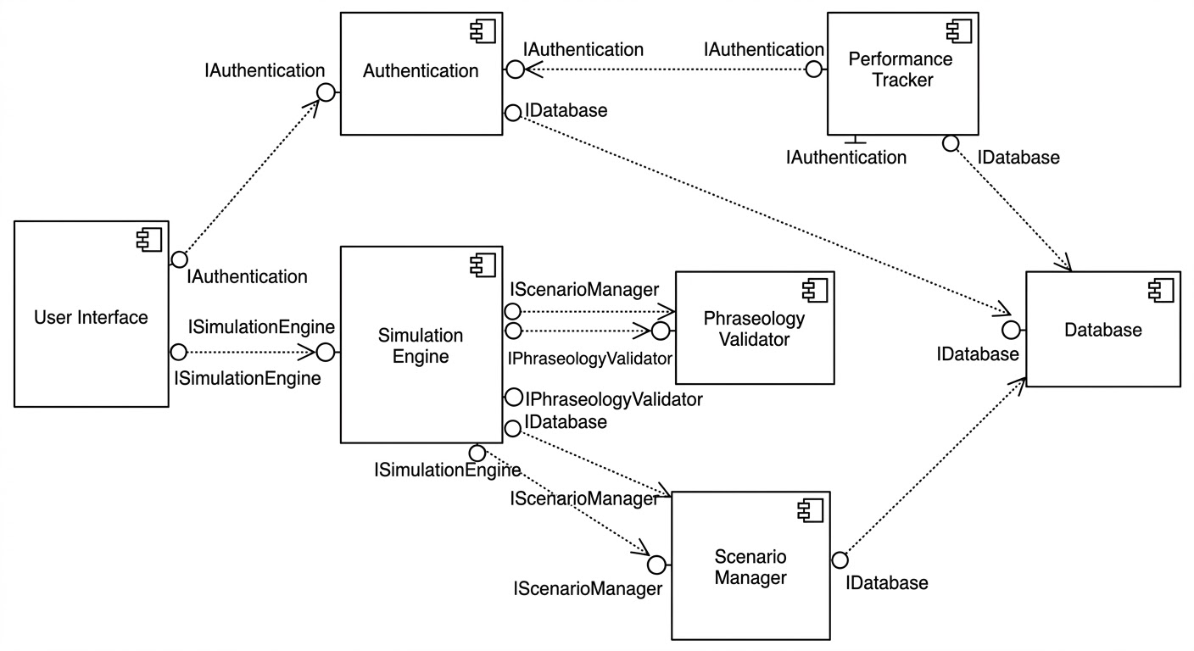

Deployment-Level Design

2.1 Physical Nodes

The system is deployed across three physical node types:
• Client Device (PC / Tablet) : Hosts the User Interface component. The trainee interacts with the system here via a lightweight cross-platform GUI. Communicates with the Application Server over HTTPS/REST.
• Application Server : Hosts the Authentication, Simulation Engine, Phraseology Validator, Scenario Manager, and Performance Tracker components. Processes all business logic and exposes a REST API to the client. Communicates with the Database Server over an internal network connection.
• Database Server (MongoDB) : Hosts the Database component. Stores user accounts, session data, scenario configurations, active flight states, and performance logs. Accessed exclusively by the Application Server.

2.2 Communication

Source Node | Target Node | Protocol / Link
Client Device | Application Server | HTTPS / REST API over Wi-Fi or LAN
Application Server | Database Server | Internal TCP connection (MongoDB driver)
Application Server | FlightRadar24 API | HTTPS (optional, for real-world reference data)
2.3 Deployment Diagram
The UML deployment diagram below shows the three physical nodes, the software components hosted on each, and the communication links between them.
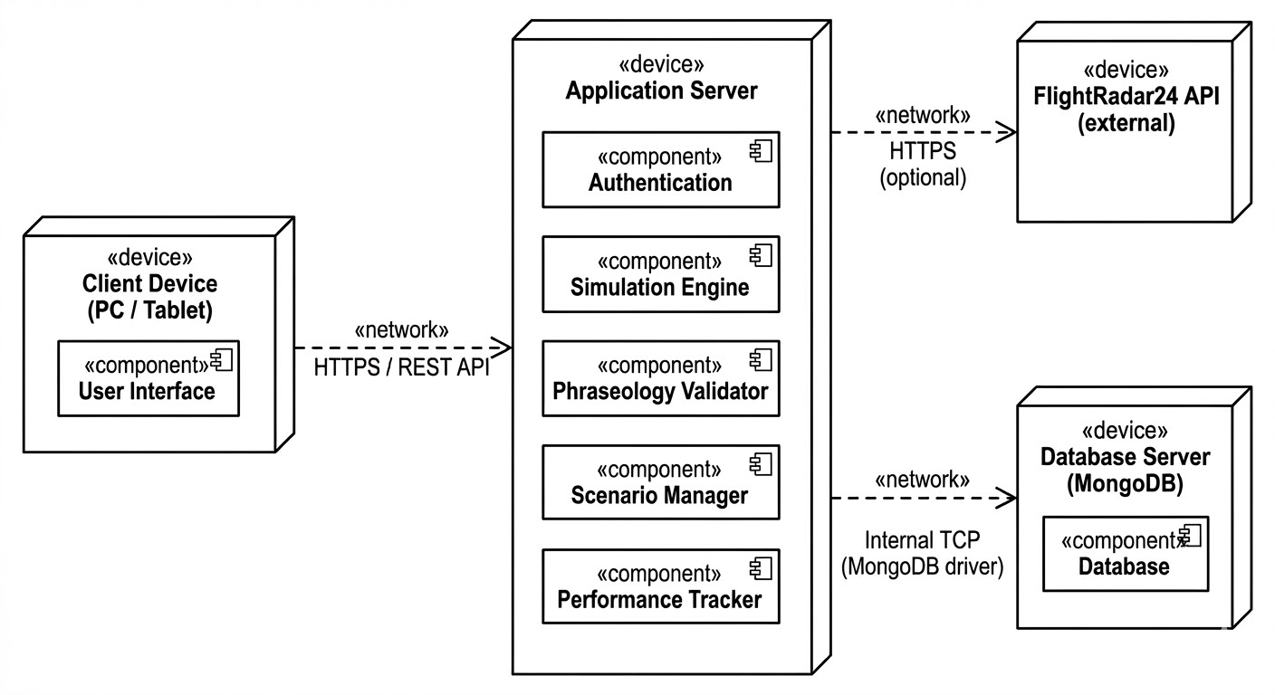

Metrics For Analysis model

Function-Based Metrics
Air Traffic Controller Educator

Step 1 : Unadjusted Function Points (UFP)
Each information domain category is identified, classified by complexity (Simple / Average / Complex), and multiplied by the standard empirical weights to produce a subtotal UFP.
Standard Complexity Weights
Category | Simple | Average | Complex
External Input (EI) | 3 | 4 | 6
External Output (EO) | 4 | 5 | 7
External Inquiry (EQ) | 3 | 4 | 6
Internal Logical File (ILF) | 7 | 10 | 15
External Interface File (EIF) | 5 | 7 | 10

UFP Count Table (Step 1 Summary)
Function Type | Simple Count × Weight | Average Count × Weight | Complex Count × Weight | Count Total (UFP)
External Inputs (EI) | 4 × 3 = 12 | 1 × 4 = 4 | 1 × 6 = 6 | 22
External Outputs (EO) | 2 × 4 = 8 | 2 × 5 = 10 | 1 × 7 = 7 | 25
External Inquiries (EQ) | 2 × 3 = 6 | 2 × 4 = 8 | 0 × 6 = 0 | 14
Internal Logical Files (ILF) | 0 × 7 = 0 | 3 × 10 = 30 | 1 × 15 = 15 | 45
External Interface Files (EIF) | 0 × 5 = 0 | 1 × 7 = 7 | 0 × 10 = 0 | 7
Total UFP |  |  |  | 113

External Inputs (EIs) — Subtotal: 22
An external input is any data or control information entered into the system from outside its boundary.
External Input | Complexity | Weight | UFP
User Registration | Simple | 3 | 3
User Login | Simple | 3 | 3
ATC Phraseology Command Input | Average | 4 | 4
Sector / Scenario Selection | Simple | 3 | 3
Admin: Create / Edit Scenario | Complex | 6 | 6
Admin: Add / Remove User | Simple | 3 | 3
Subtotal |  |  | 22
External Outputs (EOs) — Subtotal: 25
An external output is any data derived from within the system and presented to the user, such as reports, displays, or alerts.
External Output | Complexity | Weight | UFP
Phraseology Validation Feedback | Simple | 4 | 4
Real-time Radar Display Update | Complex | 7 | 7
Session Performance Report | Average | 5 | 5
Progress Dashboard | Average | 5 | 5
Error / Warning Messages | Simple | 4 | 4
Subtotal |  |  | 25

External Inquiries (EQs) — Subtotal: 14
An external inquiry is an online input that results in an immediate online output, typically retrieving data from an ILF.
External Inquiry | Complexity | Weight | UFP
View Trainee Progress | Simple | 3 | 3
Search / Filter Scenarios | Simple | 3 | 3
View Session History | Average | 4 | 4
Real-time Aircraft Status | Average | 4 | 4
Subtotal |  |  | 14

Internal Logical Files (ILFs) — Subtotal: 45
An internal logical file is a logical grouping of data maintained within the application boundary via external inputs.
Internal Logical File | Complexity | Weight | UFP
User Accounts | Average | 10 | 10
Session and Score Logs | Average | 10 | 10
Scenario Configurations | Complex | 15 | 15
Active Flight Data | Average | 10 | 10
Subtotal |  |  | 45

External Interface Files (EIFs) — Subtotal: 7
An external interface file is a logical grouping of data residing outside the application boundary that the system reads or references.
External Interface File | Complexity | Weight | UFP
FlightRadar24 API Data | Average | 7 | 7
Subtotal |  |  | 7

UFP Summary
Information Domain | UFP Subtotal
External Inputs (6 items) | 22
External Outputs (5 items) | 25
External Inquiries (4 items) | 14
Internal Logical Files (4 items) | 45
External Interface Files (1 item) | 7
Total UFP | 113

Step 2 : Complexity Adjustment Factor (CAF)
The CAF adjusts the UFP count based on 14 General System Characteristics (GSCs). Each factor is rated on a scale of 0 to 5 as follows: 0 — No Influence, 1 — Incidental, 2 — Moderate, 3 — Average, 4 — Significant, 5 — Essential.
CAF = 0.65 + ( 0.01 × ΣFi )
# | General System Characteristic | Rating (0–5)
1 | Reliable backup and recovery | 3
2 | Specialized data communications | 2
3 | Distributed processing | 2
4 | Performance critical | 4
5 | Heavily utilized operational environment | 2
6 | Online data entry | 5
7 | Input over multiple screens / operations | 3
8 | ILFs updated online | 4
9 | Complex inputs, outputs, files, inquiries | 3
10 | Complex internal processing | 4
11 | Reusable code | 3
12 | Conversion and installation | 2
13 | Multiple installations | 2
14 | Ease of use / facilitate change | 4
ΣFi | Sum of all 14 ratings | 43

CAF = 0.65 + ( 0.01 × 43 ) = 1.08

Step 3 : Function Points (FP)
FP = UFP × CAF = 113 × 1.08 = 122.04
The ATC Training System has a functional size of 122.04 Function Points. Using a typical productivity reference of 10 development hours per Function Point, the estimated effort is 122.04 × 10 = 1,220 hours.
Summary
Metric | Value
Total EIs | 6
Total EOs | 5
Total EQs | 4
Total ILFs | 4
Total EIFs | 1
Unadjusted Function Points (UFP) | 113
ΣFi (sum of VAF ratings) | 43
Complexity Adjustment Factor (CAF) | 1.08
Final Function Points (FP) | 122.04

Empirical Estimation Models :
COCOMO Model

COCOMO Estimation
Air Traffic Controller Educator

LOC Estimation from Function Points
The ATC Training System has a functional size of FP = 122.04. To apply COCOMO, this is converted to an estimated Lines of Code figure using a standard language-specific reference rate.
Assuming python with 40 lines of code per FP,

Estimated LOC = FP × LOC/FP = 122.04 × 40 = 4881 lines
KLOC = 4881 / 1000 = 4.882 KLOC

Basic COCOMO Model
The Basic COCOMO model provides a first-order estimate using only KLOC as input. The formulas are:
Effort ( E ) = A × (KLOC)ᴮ [person-months]
Time ( T ) = C × (E)ᴰ [months]
Persons ( P ) = E / T
Constants by Project Mode
Project Mode | A | B | C | D
Organic | 2.4 | 1.05 | 2.5 | 0.38
Semi-Detached | 3.0 | 1.12 | 2.5 | 0.35
Embedded | 3.6 | 1.20 | 2.5 | 0.32
Basic COCOMO Results (KLOC = 4.882)

Organic Mode
E = 2.4 × (4.882)^1.05 = 12.68 person-months
T = 2.5 × (12.68)^0.38 = 6.56 months
P = 12.68 / 6.56 = 1.93 persons
Semi-Detached Mode
E = 3.0 × (4.882)^1.12 = 17.72 person-months
T = 2.5 × (17.72)^0.35 = 6.84 months
P = 17.72 / 6.84 = 2.59 persons
Embedded Mode
E = 3.6 × (4.882)^1.2 = 24.13 person-months
T = 2.5 × (24.13)^0.32 = 6.92 months
P = 24.13 / 6.92 = 3.49 persons

Summary — Basic COCOMO
Project Mode | Effort (PM) | Time (months) | Persons required
Organic | 12.68 | 6.56 | 1.93
Semi-Detached | 17.72 | 6.84 | 2.59
Embedded | 24.13 | 6.92 | 3.49
For the ATC Educator (Semi-Detached), the Basic COCOMO model estimates 17.72 person-months of effort, a development schedule of 6.84 months, and a team size of 2.59 persons.

Intermediate COCOMO Model
The Intermediate COCOMO model refines the basic estimate by introducing 15 Cost Drivers. The product of all 15 multipliers is the Effort Adjustment Factor (EAF).
Effort ( E ) = ( A × (KLOC)ᴮ ) × EAF [person-months]
EAF = ∏ (all 15 cost driver values)
Time ( T ) = C × (E)ᴰ
Persons ( P ) = E / T
The Intermediate model constants for Semi-Detached are: A = 3.0, B = 1.12, C = 2.5, D = 0.35.

Cost Driver Ratings for ATC Educator
Each of the 15 cost drivers is rated below with a justification specific to the ATC Training System:
CD# | Cost Driver | Rating | Value | Justification
1 | Required software reliability | VH | 1.4 | Trainee progress and session data must not be lost
2 | Database size | N | 1.0 | Moderate volume — user records, sessions, scenarios
3 | Product complexity | H | 1.15 | Real-time simulation, separation logic, ICAO validation
4 | Runtime performance constraints | H | 1.11 | Sub-2 second response required during live simulation
5 | Memory constraints | N | 1.0 | Standard desktop hardware, no tight memory limits
6 | VM environment volatility | L | 0.87 | Stable OS target (Windows / Linux), no frequent changes
7 | Required turnabout time | N | 1.0 | Normal interactive response expected
8 | Analyst capability | N | 1.0 | BCA-level, solid understanding of domain requirements
9 | Software engineering capability | N | 1.0 | Standard OOP and modular design practices applied
10 | Applications experience | L | 1.17 | Limited prior experience building simulation systems
11 | VM experience | H | 0.9 | Familiar with Python runtime and development tools
12 | Programming language experience | H | 0.95 | Proficient in Python; experience with GUI frameworks
13 | Use of software tools | N | 1.0 | Standard IDE, version control, basic tooling
14 | Software engineering methods | N | 1.0 | Structured methods applied; no advanced CASE tools
15 | Required development schedule | N | 1.0 | Academic timeline — not artificially compressed
EAF | Product of all cost driver values |  | 1.5553

Intermediate COCOMO Calculation (Semi-Detached, KLOC = 4.882, EAF = 1.5553)
E_base = 3.0 × (4.882)^1.12 = 17.72 person-months
E = 17.72 × 1.5553 = 27.56 person-months
T = 2.5 × (27.56)^0.35 = 7.98 months
P = 27.56 / 7.98 = 3.45 persons

